Name: __________________________________________ Hour________ Score_________/50
Product Advertisement
Criteria | EXEMLARY  50-40 | GOOD  39-30 | NEEDS IMPROVEMENT  29- LOWER
1. The student created a fictional product or place, created a fictional ad for it. 30 pts
2. The student gave a brief description of their product or place in their ad, and turned in 1 paragraph describing their product or place. 10pts

3. The student explained their color choices that aligned with their target audience and the feelings they hoped to inspire with their product or place, as well as filled in all information about their target audience.
5 pts

4. The student used good craftsmanship in their artwork (all lines were drawn, and cut nicely, color is inside the lines).
5 pts

Teacher’s comments:

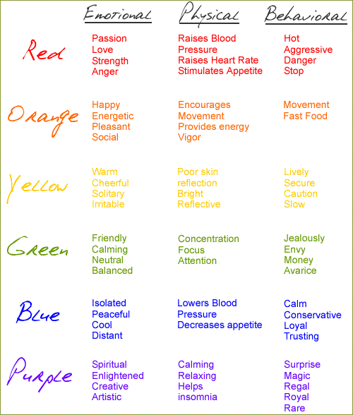
Target Audience: Who does your product appeal to?
Male or Female:
Age:
Income Level:
Explain why you chose the colors for your ad/product in the space below
Write 1 paragraph describing your product:

