Name: __________________________________________ Hour________ Score_________/50
Product Advertisement
Criteria | EXEMLARY  50-40 | GOOD  39-30 | NEEDS IMPROVEMENT  29- LOWER
1. The student created a product either in 2-D or
3-D form and created a fictional ad for it. 30 pts
2. The student explained their color choices that aligned with their target audience and the feelings they hoped to inspire with their product, as well as filled in all information about their target audience.
5 pts
3. The student created a logo with a color scheme that was explained with color psychology. 5 pts
4. The student gave a brief description of their product in their ad, and turned in 1 paragraph describing their product. 5pts

5. The student used good craftsmanship in their artwork (all lines were drawn, and cut nicely, color is inside the lines).
5 pts

Teacher’s comments:

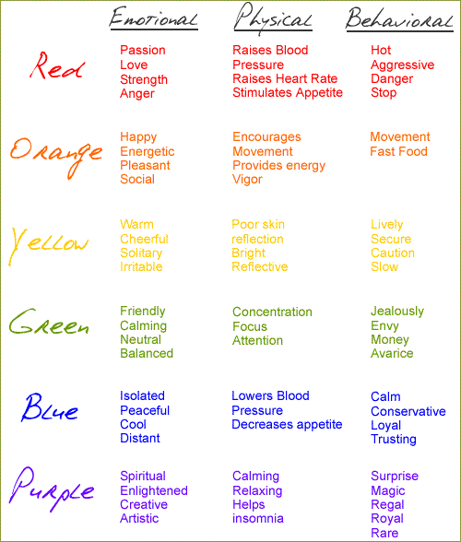
Target Audience: Who does your product appeal to?
Male or Female:
Age:
Income Level:
Logo: Draw your logo in the box below What colors did you use for your logo? Why?
Explain why you chose the colors for your ad/product in the space below
Write 1 paragraph describing your product:

